**A Project report**

**on**

**” Bank Management System”**

*Submitted in partial fulfillment of the requirements*

*for the degree of*

**Master of Computer Application**

*By*

**Harshad Padmakar Karan**

**PRN:-23030332241004**

*under the guidance of*

**Prof. Dr. V. J. Kadam**



**Department of Information Technology**

**Dr. Babasaheb Ambedkar Technological University,**

**Lonere-402103, Dist. Raigad, (MS) INDIA.**

**A.Y. 2024-25**

**Certificate**



A project report,*”****Bank Management System****”* submitted by ***Harshad Padmakar Karan (23030332241004)***, is approved for the partial fulfillment of the requirements for the degree of **Master Of Computer Application (MCA)**in Dr. Babasaheb Ambedkar Technological University, Lonere - 402 103, Raigad (MS).

**Dr. V. J. Kadam Dr. Shivajirao M. Jadhav**

**Guide Head Of Department, IT**

Place: Dr. Babasaheb Ambedkar Technological University, Lonere - 402103.

Date: 22 February 2025

**I**

**Acknowledgment**

Our first and foremost words of recognition go to our highly esteemed Guide for his constructive academic advice and guidance, constant encouragement and valuable suggestions, and all other supports and kindness to us. His supervision and guidance proved to be the most valuable to overcome all the hurdles in the completion of this report.

I am also thankful to Head of Department, Dr. Shivajirao M. Jadhav for his guidance and valuable suggestions. We would also like to thank our departmental staff, library staff for their timely help.

Finally, we would like to thank all whose direct and indirect support helped us in completing this report in time.

**Abstract**

The **"Bank Management System"** is a Java-based application aimed at automating and streamlining banking operations. By leveraging technologies like Java, AWT, Swing, SQL (MySQL), and JDBC, the system provides a secure and user-friendly platform for managing customer records, accounts, and transactions. It includes core functionalities such as adding and updating customer details, handling deposits and withdrawals, and generating transaction histories. Designed for scalability and efficiency, the project emphasizes secure database interactions and a visually appealing graphical user interface (GUI). This system not only enhances operational efficiency but also serves as a foundation for further advancements like mobile app integration and AI-based fraud detection.

**Contents**

**1 Introduction to the Project** 1

1.1 About the Project 1

1.2 Motivation 2

1.3 Goals and Objectives 2

1.4 Scope 3

**2 Existing System and Disadvantage** 4

**3 Proposed System and Disadvantages** 6

**4 System Design** 8

**5 Project Requirements** 12

5.1 **Software Requirements** 12

5.2 **Hardware Requirements** 13

**6 Module Description** 14

6.1 Module:1 14

6.2 Module:2 14

6.3 Module:3 15

6.4 Module:4 15

6.5 Module:5 16

**7 Implementation** 17

**8 Result and Analysis** 21

**9 Future Work** 24

**10 Conclusion** 27

**List of Figures**

4.1 Block Diagram of Bank Management System . . . . . . . . . . . . . . . . . . . . .7  
4.2 Use Case Diagram of Banking Operations . . . . . . . . . . . . . . . . . . . . . . . . . . . .8  
5.1 GUI Design: Customer Registration Form . . . . . . . . . . . . . . . . . . . . . . . . . . .10  
5.2 GUI Design: Account Transaction Window . . . . . . . . . . . . . . . . . . . . . . . . . .11  
6.1 Class Diagram for Bank Management System . . . . . . . . . . . . . . . . . . . . . . .13  
6.2 Sequence Diagram for Money Transfer . . . . . . . . . . . . . . . . . . . . . . . . . . . . . 15  
8.1 Data Flow Diagram: Bank Transactions Module . . . . . . . . . . . . . . . . . . . . .17  
8.2 Report Generation Output: Mini Statement . . . . . . . . . . . . . . . . . . . . . ……..18

**Chapter 1**

# Introduction to the Project

## About the Project

The **Bank Management System** is a desktop application designed to manage various banking activities effectively and efficiently. The system automates essential tasks such as customer registration, account management, transaction processing, balance inquiry, and report generation. This project leverages Java's graphical capabilities through **AWT** and **Swing** for the user interface, while backend data is managed with **MySQL Workbench** using **JDBC connectivity** for database operations.

The Bank Management System is designed to enhance user experience by providing a robust, intuitive interface while maintaining high-security standards for sensitive data. Customers, bank staff, and administrators can utilize the system with clearly defined access levels to perform their respective roles seamlessly.

## 

## 1.2 Motivation

* To address the need for a systematic and automated approach to banking operations.
* To make use of **modern technologies** such as Java and MySQL to simplify tasks and minimize errors.
* To enhance customer satisfaction by improving efficiency and reducing wait times.
* To develop skills in **Java programming**, **AWT/Swing UI development**, and **database integration using JDBC**.
* To replace outdated manual or semi-digital systems with a fully automated solution.

## Goals and Objectives

• **Develop an easy-to-use desktop application** for bank-related operations.

• Implement features for account management, including account creation, update, and deletion.

• Provide a secure system for transaction processing (withdrawals, deposits, fund transfers).

• Ensure accurate and real-time retrieval of account balances and transaction histories.

• Generate detailed reports for administrative and financial analysis.

• Maintain the highest standards of **data integrity** and **security** for sensitive customer data.

## Scope

• **Application Features**:  
The system supports core banking functionalities like customer account creation, deposit and withdrawal, money transfers, and detailed reporting of transactions.

• **Technology Stack**:  
The project uses **Java AWT and Swing** for user interface design, **MySQL Workbench** for database management, and **JDBC** for smooth interaction between the application and the database.

• **Expandability**:  
This project can be further enhanced to include mobile banking features using Java for Android or APIs for web-based services.

• **Security**:  
User authentication will be implemented to ensure only authorized personnel can access sensitive operations. Data encryption and secure password storage can also be incorporated to meet industry standards.

**Chapter 2**

# Existing System and Disadvantage

**2.1 Existing System**

Traditional banking systems have long relied on manual or semi-automated processes for managing banking operations. The current systems often employ separate platforms for tasks such as account management, transaction logging, and report generation. While many banks use software solutions, they often suffer from limitations, including outdated interfaces, lack of integration between components, and limited user-friendly features.

Key components of the existing system:

* **Manual Data Entry**: Customers need to visit branches to create or modify accounts, leading to delays.
* **Fragmented Software**: Different software tools are used for various banking activities, leading to inefficiencies and errors.
* **Limited Accessibility**: Current systems are confined to specific devices or locations, making it difficult to scale operations.

**2.2 Disadvantages**

1. **Time-Consuming Operations**:  
   Manual or semi-automated processes often result in delays for both customers and staff, especially during account setup and transactions.
2. **Human Error**:  
   Manual data entry increases the chances of typographical errors, affecting records' accuracy and customer satisfaction.
3. **Lack of Integration**:  
   Inconsistent integration between software modules means essential operations such as real-time account updates and transaction history retrieval are slower and less reliable.
4. **Limited Data Security**:  
   Many existing systems do not meet modern data encryption and authentication standards, increasing the risk of breaches and data misuse.
5. **Inefficiency in Report Generation**:  
   Generating comprehensive financial reports is often a labor-intensive process due to unorganized data and lack of automation.
6. **Restricted Usability**:  
   Traditional software often requires specialized training to use, which can discourage adoption by less tech-savvy staff and customers.
7. **Lack of Scalability**:  
   Expanding the system to accommodate more customers or services is challenging in legacy systems, limiting the bank's ability to grow its operations seamlessly.

**Chapter 3**

# Proposed System and Disadvantages

**3.1 Proposed System**

The **proposed Bank Management System** is a robust and automated software application that integrates core banking functionalities into a single platform. Designed with modern technologies such as **Java**, **AWT**, **Swing**, **MySQL**, and **JDBC**, the system enhances operational efficiency, user experience, and data security.

**Key Features of the Proposed System**:

1. **User-Friendly Interface**:  
   A visually appealing and intuitive interface created using **AWT and Swing** enables ease of use for both customers and bank staff.
2. **Centralized Data Management**:  
   All customer information, account details, and transaction histories are stored and managed securely using **MySQL**, ensuring data consistency and easy retrieval.
3. **Transaction Automation**:  
   Key banking operations, such as withdrawals, deposits, fund transfers, and balance inquiries, are fully automated, reducing manual intervention and errors.
4. **Role-Based Access**:  
   User authentication ensures that administrators, staff, and customers can access functionalities based on predefined roles, enhancing system security.
5. **Enhanced Reporting**:  
   The system can generate detailed reports, such as daily transaction summaries, account status reports, and financial analyses, supporting informed decision-making.
6. **Data Security**:  
   By leveraging JDBC and database encryption techniques, the proposed system ensures secure transmission and storage of sensitive customer data.
7. **Real-Time Updates**:  
   Transactions and account modifications are updated instantly across the system, ensuring accuracy and availability of information.

**3.2 Disadvantages**

While the proposed system offers significant improvements over traditional methods, there are a few limitations:

1. **Learning Curve for New Users**:  
   Users unfamiliar with technology or banking software might need initial training to navigate and utilize the system efficiently.
2. **Dependency on Technology**:  
   The system relies heavily on the internet and server availability. Any downtime could disrupt services temporarily.
3. **Implementation Cost**:  
   Initial setup costs, including software development, hardware procurement, and staff training, may be higher for smaller banks.
4. **Maintenance Requirements**:  
   Regular updates and maintenance of the database and application are necessary to ensure seamless functionality, which might require technical expertise.
5. **Data Migration**:  
   Transitioning from legacy systems to the new system could involve challenges in data migration, especially if existing records are inconsistent or incomplete.

**Chapter 4**

# System Design

**4.1 System Architecture**

The architecture of the **Bank Management System** is designed to provide a robust and secure environment for managing bank operations. The system is built on **Java** using **Swing** for the front-end user interface, **MySQL** for database management, and **JDBC** for backend connectivity.

**Key Components of the Architecture**:

1. **Frontend**:  
   The graphical user interface (GUI) is developed using Java **AWT** and **Swing** to provide an intuitive and visually appealing experience for users.
2. **Backend**:  
   The backend functionality integrates business logic written in Java with the database using **JDBC connectivity** to handle queries and transactions.
3. **Database**:  
   **MySQL Workbench** is used as the database management system, storing all essential data such as customer details, account information, transaction history, and login credentials.

**Layers of the Architecture**:

* **Presentation Layer**: The GUI that interacts with users, allowing them to perform tasks such as account creation, deposits, withdrawals, and report generation.
* **Business Logic Layer**: Java methods handle user requests, verify data, and enforce banking rules such as maintaining minimum balances.
* **Data Layer**: The database manages persistent data and ensures secure storage and retrieval.

**4.2 Block Diagram**

**Figure 4.1: Block Diagram** (to be visualized as follows):

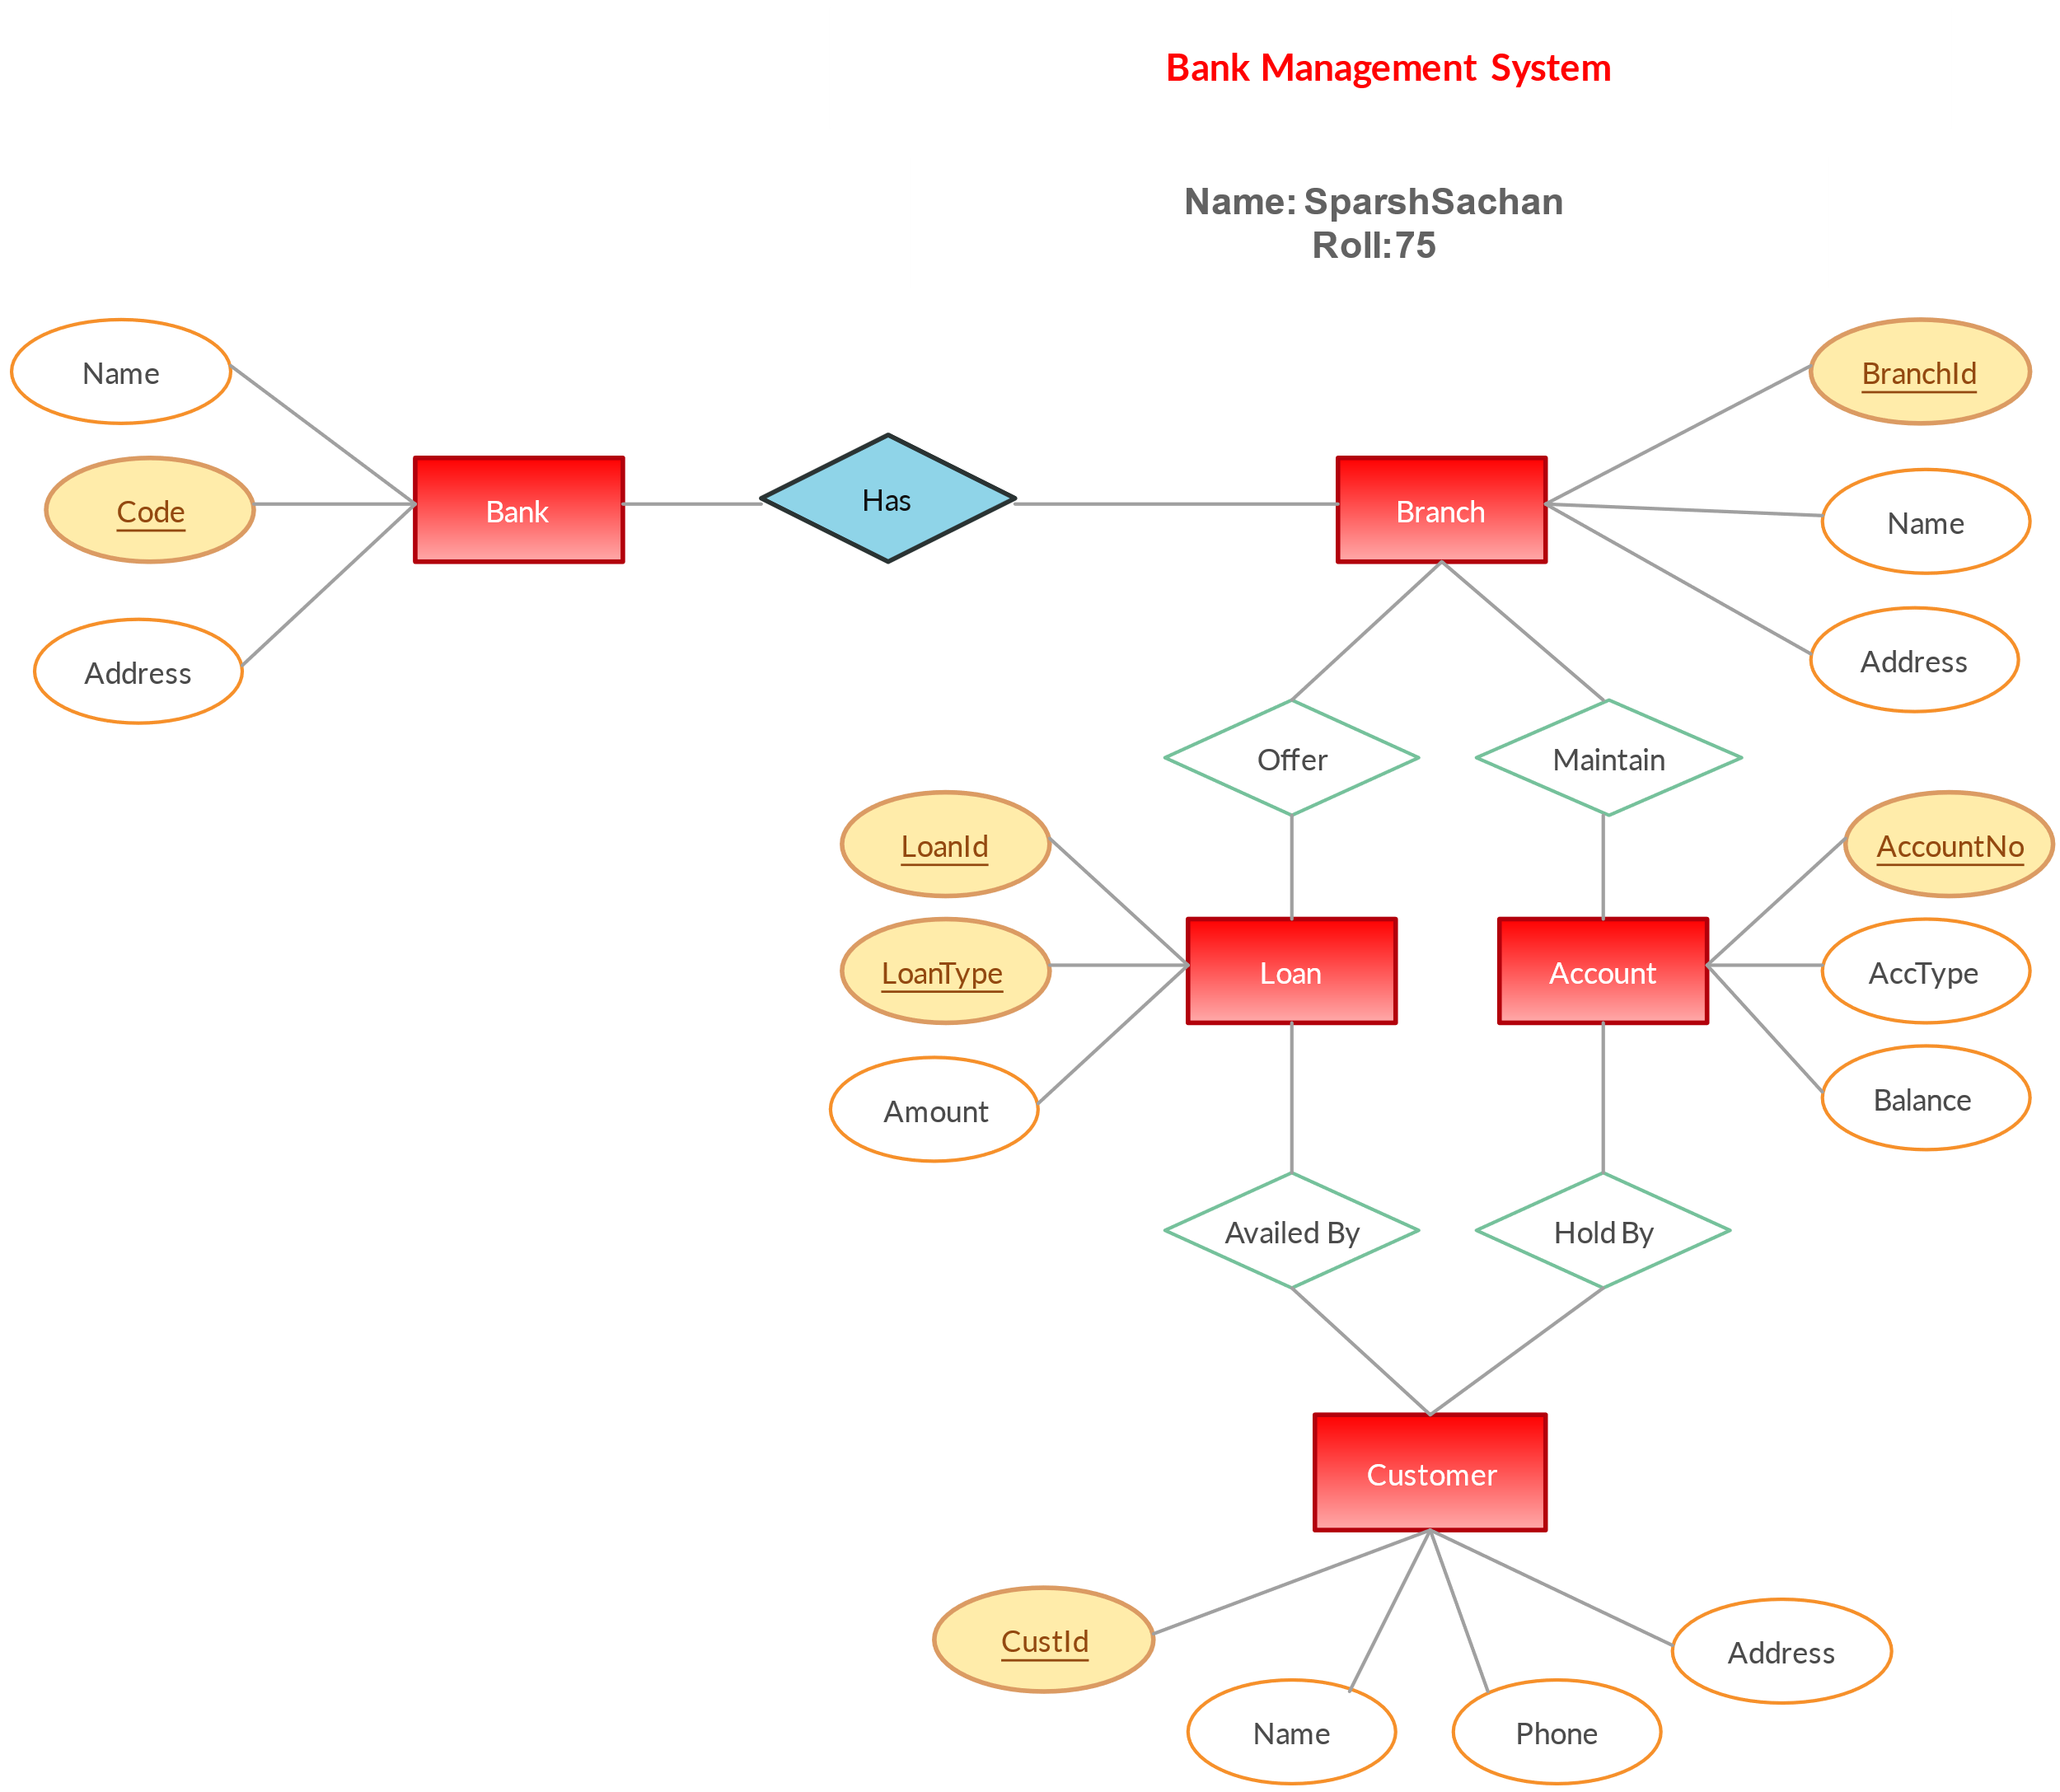

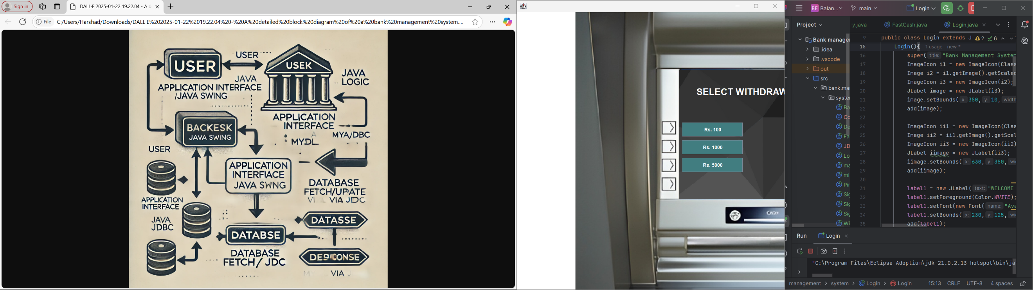

**4.3 Use Case Diagram**

**Figure 4.2: Use Case Diagram** (key stakeholders and system functionalities):

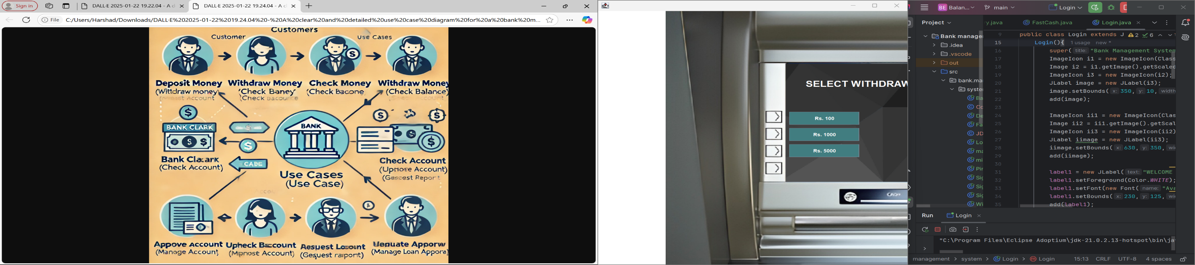

**4.4 Key Files/Modules**

1. **Main.java**: The entry point of the application where the user is directed to the login screen.
2. **Login.java**: Handles user authentication based on the type of user (customer, staff, administrator).
3. **DatabaseConnection.java**: Manages JDBC connectivity between the Java application and MySQL database.
4. **AccountManagement.java**: Facilitates account creation, update, and deletion tasks.
5. **TransactionModule.java**: Manages all financial operations, such as deposits, withdrawals, and fund transfers.
6. **ReportGenerator.java**: Allows staff and administrators to generate reports for audits or analyses.

**Chapter 5**

# Project Requirements

**5.1 Software Requirements**

The software requirements for the **Bank Management System** are as follows:

* **Programming Language**:  
  Java (JDK 8 or later) is used for application development. It provides support for graphical user interfaces, backend logic, and database connectivity.
* **Frameworks/Libraries**:
  + **AWT and Swing**: For creating a graphical user interface (GUI).
  + **JDBC (Java Database Connectivity)**: For connecting to and interacting with the database.
* **Database**:  
  **MySQL Workbench** is used as the relational database management system to store customer data, account details, transaction histories, and logs.
* **Integrated Development Environment (IDE)**:  
  Preferred IDEs for development include **Eclipse** or **IntelliJ IDEA**.
* **Operating System**:  
  The application is compatible with any system running **Windows**, **macOS**, or **Linux**.

**5.2 Hardware Requirements**

The hardware requirements for the system to run effectively are minimal and include:

* **Processor**: Dual-Core Processor (Intel i3 or equivalent and above).
* **RAM**: Minimum 4 GB (8 GB or higher recommended for faster processing).
* **Storage**: Minimum 500 MB free space for application files and database.
* **Display**: Resolution of 1024x768 or higher.
* **Input Devices**: Standard keyboard and mouse for operation.

**Chapter 6**

# Module Description

The **Bank Management System** is designed using modular architecture to streamline implementation, testing, and maintenance. The application is divided into several modules that handle different functionalities independently.

**6.1 Module 1: User Authentication**

**Purpose**: To ensure only authorized users (customers, staff, administrators) access the system.

**Features**:

* Login functionality with username and password.
* Role-based access (e.g., customers access account details, staff manage transactions, administrators oversee the system).
* Password encryption for enhanced security using hashing algorithms.

**Implementation**:

* The login interface is created using **AWT and Swing**.
* A user database table contains credentials and roles, verified via **JDBC queries** during login attempts.

**6.2 Module 2: Customer Management**

**Purpose**: To handle customer-related operations, such as registration and account updates.

**Features**:

* New customer registration with unique account numbers.
* Modifications to customer details such as address or contact information.
* Deletion of inactive or fraudulent accounts.

**Implementation**:

* Backend logic is handled in Java methods, ensuring data validation.
* Data is stored and managed using **MySQL**, with updates performed via **JDBC**.
* Swing-based forms collect customer information, interactively updating the database.

**6.3 Module 3: Transactions Management**

**Purpose**: To perform banking operations such as deposits, withdrawals, and fund transfers.

**Features**:

* Deposit and withdrawal functionalities update balances in real-time.
* Fund transfers between accounts, with validation for sufficient balance.
* Balance inquiries and mini-statements.

**Implementation**:

* GUI elements like buttons and input fields facilitate user interaction.
* Transaction details are stored in a separate database table for accurate tracking.

**6.4 Module 4: Report Generation**

**Purpose**: To provide administrators and staff with detailed and customizable reports.

**Features**:

* Daily transaction reports for audits.
* Customer account summaries for management purposes.
* Error logs to identify and resolve issues.

**Implementation**:

* Java handles report creation by retrieving data through SQL queries.
* Generated reports can be displayed on the application interface or exported in formats like PDF or CSV.

**6.5 Module 5: Database Management**

**Purpose**: To handle backend storage and ensure the integrity of data.

**Features**:

* Structured storage of customer information, account details, and transaction histories.
* Data retrieval through optimized queries to enhance system performance.
* Regular backup routines to prevent data loss.

**Implementation**:

* **MySQL Workbench** creates tables and manages relationships between entities.
* JDBC serves as the middleware to interact with the database securely.

**Collaboration**

The project development was a collaborative effort among all team members:

* **Module Assignment**: Each team member contributed to one or more modules, ensuring streamlined progress.
* **Code Integration**: Regular reviews ensured all modules integrated seamlessly into the application.

**Chapter 7**

# Implementation

The implementation of the **Bank Management System** involves various steps to ensure the application functions seamlessly and efficiently. Each module is implemented using a systematic approach integrating Java, JDBC, and MySQL.

**7.1 Steps for Implementation**

1. **User Authentication**
   * **Input**: Username and password entered by the user in the login form.
   * **Process**:
     + Validate the credentials by comparing them against the user database in MySQL.
     + Role-based access control to ensure users only access relevant sections.
   * **Output**: A successful login allows users to access specific functionalities, while unsuccessful attempts prompt error messages.
2. **Customer Account Management**
   * **Input**: User-provided data for account creation or updates via GUI forms.
   * **Process**:
     + Validate inputs for correctness and completeness.
     + Insert, update, or delete records in the database using JDBC queries.
   * **Output**: Confirmation messages indicating the success or failure of operations.
3. **Transactions**
   * **Input**: Amounts for deposits, withdrawals, or transfers provided by the user.
   * **Process**:
     + Verify account balances and validate the transaction.
     + Update the database in real-time to reflect changes in balances.
     + Log each transaction for record-keeping and reporting.
   * **Output**:
     + Updated account balance displayed to the user.
     + Confirmation receipt or message for the transaction.
4. **Report Generation**
   * **Input**: Request for a report type (e.g., transaction history, daily reports).
   * **Process**: Execute SQL queries to retrieve relevant data and format it for display or export.
   * **Output**: Reports presented on the GUI or saved as a downloadable file (PDF, CSV).

**7.2 Key Functionalities**

1. **Database Operations**:
   * Data is stored in tables (e.g., users, accounts, transactions) in the MySQL database.
   * CRUD operations (Create, Read, Update, Delete) are implemented using **JDBC** queries for secure and efficient data handling.
2. **GUI Design**:
   * The application interface is developed using **Java Swing** for interactive forms, buttons, and tables.
   * GUI elements allow users to input data, view account details, and perform transactions.
3. **Data Validation**:
   * User inputs are validated at the front end to prevent SQL injection attacks and ensure data accuracy.
4. **Error Handling**:
   * Exception handling is implemented in Java to manage errors such as invalid inputs or database connection issues.
   * Descriptive error messages guide users to correct their actions.

**7.3 Tools and Technologies**

* **Java**: Provides a robust platform for GUI design and backend development.
* **JDBC**: Facilitates secure and reliable communication between Java and the MySQL database.
* **MySQL Workbench**: Manages database schemas, tables, and relationships.
* **Eclipse/IntelliJ IDEA**: Serves as the integrated development environment for coding and debugging.

**7.4 Sample Process Flow**

* A user logs into the system via the **login screen**.
* After successful authentication, they navigate to the **dashboard**, where options for account management, transactions, or report generation are available.
* Upon selecting a specific option, the **backend processes the request**, retrieves or updates data in the database, and presents results via the GUI.

**Chapter 8**

# Result and Analysis

**Results:**

The implementation of the **Bank Management System** has resulted in a robust application capable of managing core banking functions efficiently. The following modules were successfully developed and tested:

1. **User Authentication**:
   * Secure and reliable login system.
   * Role-based access control ensures appropriate permissions.
2. **Customer Account Management**:
   * Accurate creation, updating, and deletion of account details.
   * Validation mechanisms prevent erroneous data entry.
3. **Transactions**:
   * Real-time updates of account balances for deposits, withdrawals, and transfers.
   * Transaction history maintained securely for audits.
4. **Report Generation**:
   * Comprehensive daily transaction logs.
   * Exportable account summaries and audit reports in multiple formats (PDF, CSV).

**Analysis:**

1. **Efficiency**:
   * The **Java Swing-based GUI** is user-friendly and processes tasks efficiently.
   * Transactions are completed in real-time with minimal delay due to optimized **JDBC queries**.
2. **Accuracy**:
   * Database operations ensure high accuracy in data storage and retrieval.
   * Validation checks minimize errors during input and transaction processes.
3. **Security**:
   * Password encryption secures user credentials.
   * Role-based access restricts unauthorized usage, enhancing system integrity.
4. **Scalability**:
   * The system is designed to handle an increasing number of customers and transactions by utilizing an efficient **MySQL database schema**.

**Visual Representations**

1. **Login Screen**  
   *A functional interface for user authentication.*  
   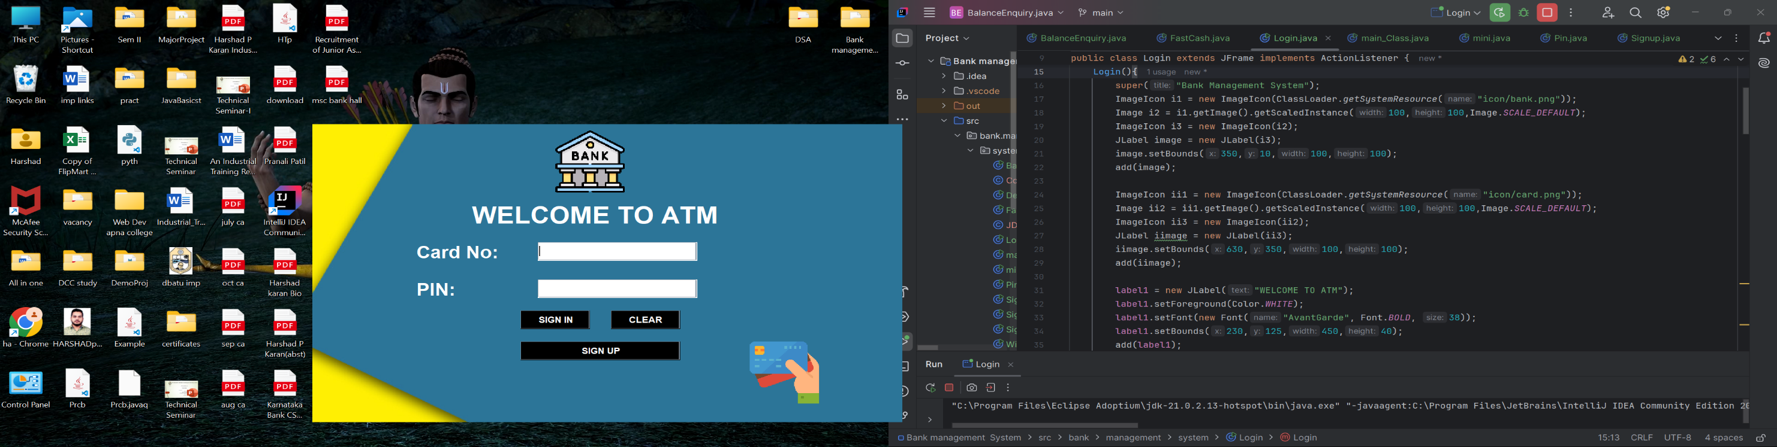
2. **Customer Management**  
   *GUI representation for adding or editing customer details.*

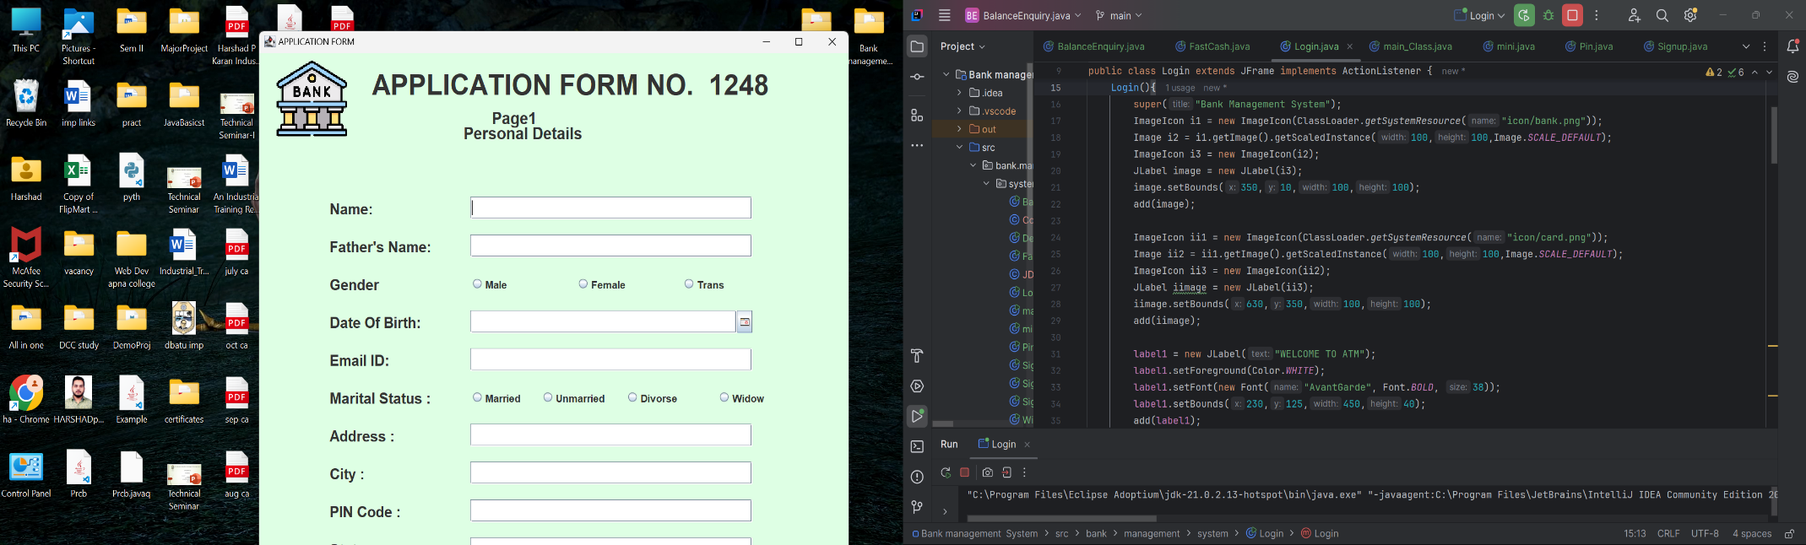

1. **Transaction Screen**  
   *Real-time deposit, withdrawal, and balance inquiry interface.*
2. 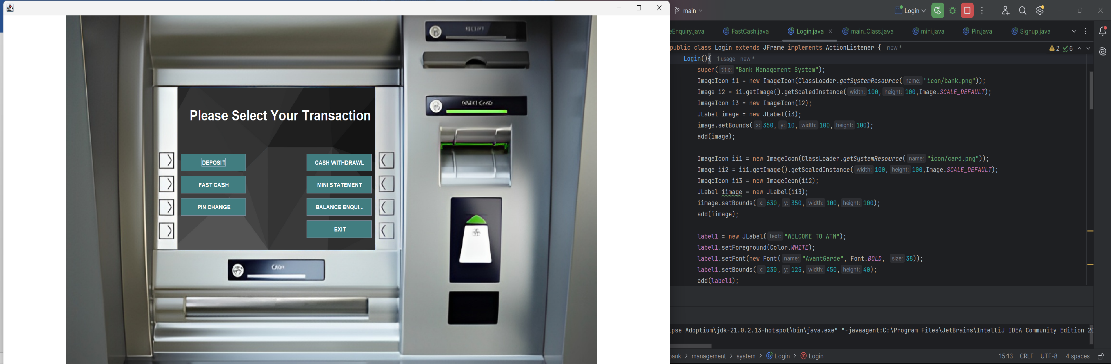

**Chapter 9**

# Future Work

The **Bank Management System** can be enhanced and extended with additional features to meet evolving user needs and technological advancements. Some of the possible future developments include:

**9.1 Enhanced Security Features**

* **Two-Factor Authentication (2FA)**:  
  Adding an extra layer of security by integrating 2FA through SMS, email, or mobile apps for user authentication.
* **Biometric Authentication**:  
  Implementing fingerprint or facial recognition to enhance security and convenience for users.

**9.2 Integration with Third-Party Services**

* **Payment Gateway Integration**:  
  Enabling customers to pay bills, recharge, and make online purchases directly through the banking application.
* **UPI and QR Code Transactions**:  
  Incorporating UPI-based payment systems and QR code scanning for fast and seamless transactions.

**9.3 Mobile Application Development**

* Designing and developing a mobile app to allow users to access their accounts on the go.
* Features like push notifications for transactions, balance updates, and promotional offers can enhance the user experience.

**9.4 Advanced Reporting and Analytics**

* **AI-Based Insights**:  
  Integrating artificial intelligence to analyze transaction patterns and provide actionable insights for customers, such as saving suggestions or fraud detection.
* **Customizable Reports**:  
  Allowing users and administrators to generate customized reports based on specific criteria.

**9.5 Support for Multiple Currencies and Accounts**

* Enabling international transactions by incorporating support for multiple currencies.
* Providing options for managing multiple accounts under a single user profile for convenience.

**9.6 Automation and AI-Driven Chatbots**

* **Automated Support**:  
  Implementing AI-driven chatbots to assist users with common queries and perform basic transactions.
* **Loan and Investment Advisory**:  
  Using machine learning algorithms to offer personalized recommendations for loans, investments, and savings plans.

**9.7 Cloud Integration**

* Migrating the system to a cloud-based infrastructure to ensure scalability and high availability.
* Leveraging cloud services for automated backups, disaster recovery, and enhanced system performance.

**9.8 Blockchain Integration**

* Implementing blockchain technology for secure and transparent transactions.
* Smart contracts can be used for automated loan approvals and disbursements.

**Chapter 10**

# Conclusion

**The Bank Management System has successfully met all of its project objectives and functional requirements. The system has undergone thorough testing and optimization, ensuring that it operates smoothly without bugs. All functionalities, such as customer account management, transaction processing, and report generation, have been implemented with a high level of accuracy and security.**

**The system offers a reliable and efficient solution for bank employees and customers alike. It integrates well with existing database infrastructure, enabling seamless record-keeping and real-time transactions. By utilizing Java, JDBC, and MySQL, the system provides a scalable and secure platform for daily banking operations.**

**The ultimate goal of the Bank Management System is to provide a user-friendly interface for managing banking tasks, such as deposits, withdrawals, and account inquiries. This system not only enhances the customer experience by reducing the manual effort but also ensures security through role-based access control and encrypted authentication.**

**By adopting this system, both banks and their customers can enjoy seamless operations and secure financial transactions. This system bridges the gap between technological advancements and traditional banking methods, promoting greater customer satisfaction and efficiency. Furthermore, future scalability options ensure that it can meet the growing needs of the financial sector.**